**EXP:03 Java Servlet Program to Display 'HelloWorld!' in Browser**

**AIM:**

To write a servlet program that prints **"HelloWorld!"** and displays it in the browser when accessed.

**CODE:**

package com.pavithra.servlet;

import java.io.IOException;

import javax.servlet.ServletException;

import javax.servlet.annotation.WebServlet;

import javax.servlet.http.HttpServlet;

import javax.servlet.http.HttpServletRequest;

import javax.servlet.http.HttpServletResponse;

/**

 * Servlet implementation class HelloWorld

 */

@WebServlet("/HelloWorld")

public class HelloWorld extends HttpServlet {

private static final long serialVersionUID = 1L;

    /**

     * @see HttpServlet#HttpServlet()

     */

    public HelloWorld() {

        super();

        // TODO Auto-generated constructor stub

    }

/**

* @see HttpServlet#doGet(HttpServletRequest request, HttpServletResponse response)

*/

protected void doGet(HttpServletRequest request, HttpServletResponse response) throws ServletException, IOException {

// TODO Auto-generated method stub

response.getWriter().append("Served at: ").append(request.getContextPath());

}

/**

* @see HttpServlet#doPost(HttpServletRequest request, HttpServletResponse response)

*/

protected void doPost(HttpServletRequest request, HttpServletResponse response) throws ServletException, IOException {

// TODO Auto-generated method stub

doGet(request, response);

}

}

**OUTPUT:**

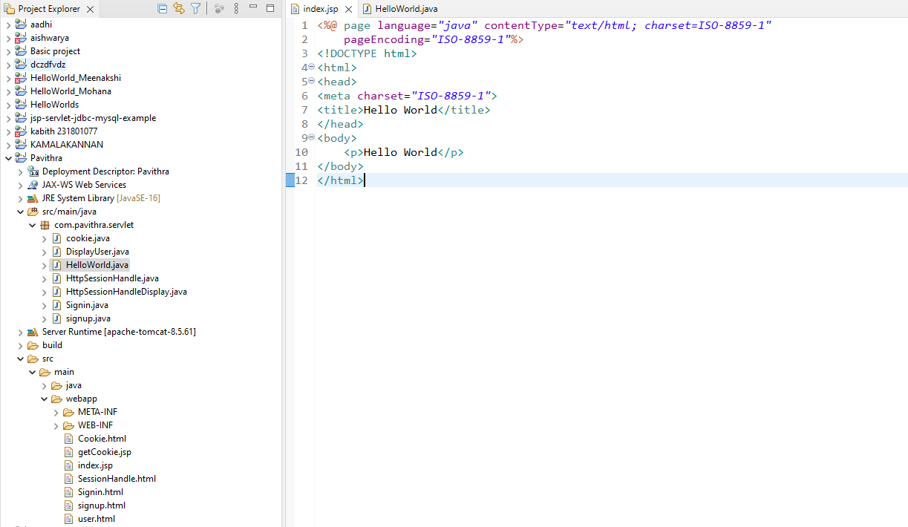

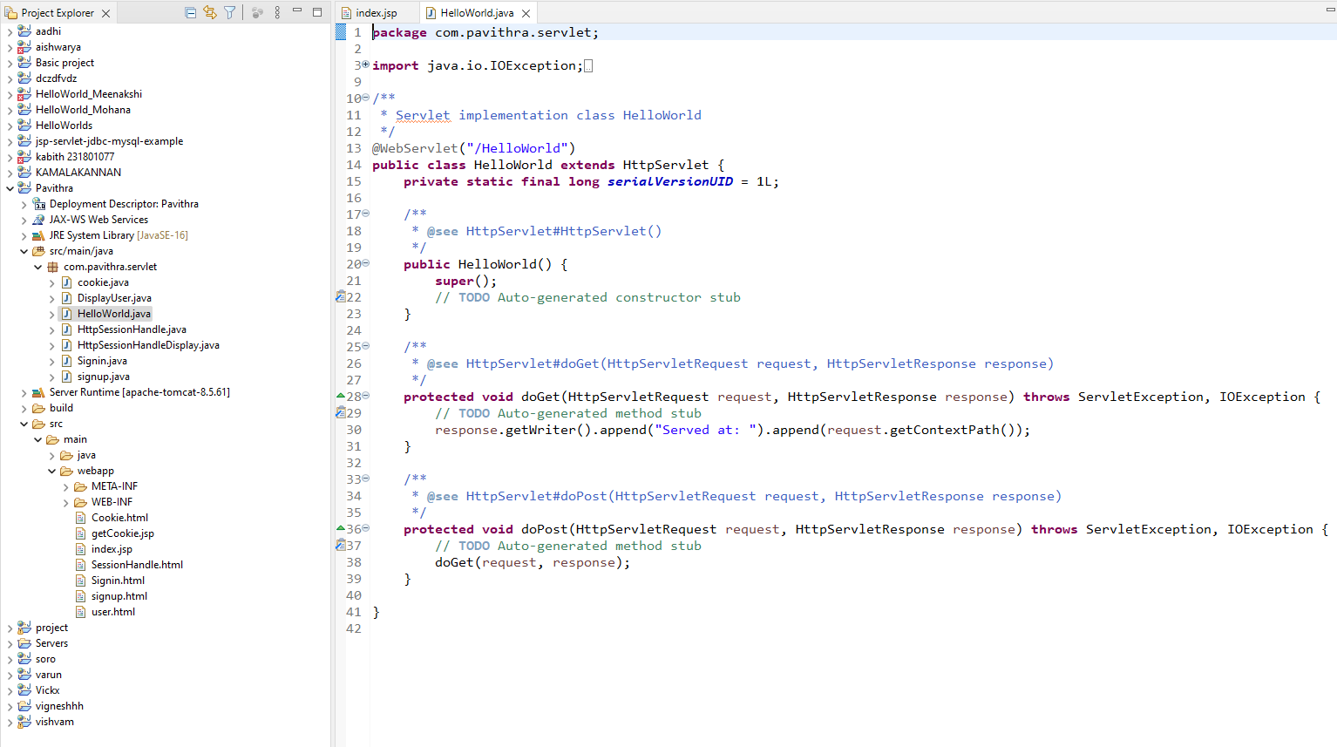

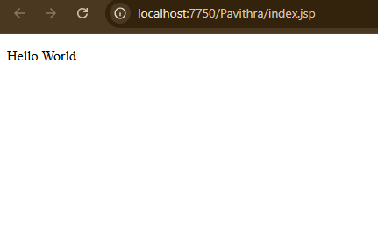

**RESULT:**

The servlet program successfully compiled and executed. It printed **"HelloWorld"** in the browser, demonstrating the use of a basic servlet using the doGet() method.